# Code Details

Written by eduard

Hi, all developers.

I ‘d like to explain UI (written by me).

1. Pre-Details

I divided our UI as follows.

* A is LeftX component.
* B is RightX component.
* A1 is TopX component. This is one part of A up.
* A2 is BottomX component.This is one part of A down.
* A2a is LeftB[N] componet.This is one part of A2.Here [N] is one of 1 or 2, and then if you choose 1, will display the main page. If you choose 2, will display the recipe page

For example if you want to display main page, You have to select the LeftB1, RightB1, TopX and RightX components.

if you want to display receip page, You have to select the LeftB2, RightB2, TopX and RightX components.

My project contains React-Redux.

And all views is wrriten by Tailwindcss frame work.

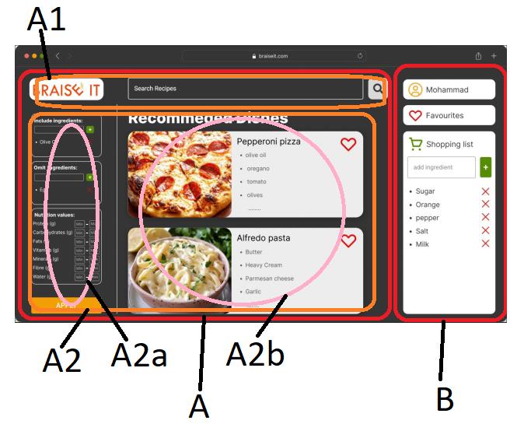

2.Main Page

The main idea of Redux is that every display is consist of small component.

If you display this page, you have to go src/containers/leftX/bottomX/BottomX.js.

And select part1 as follows.

 return (

    <div className='w-full flex flex-row mt-10 space-x-10'>

     {/* // Part1 */}

      <LeftB1 />

      <RightB1/>

      {/* // Part2          */}

      {/* <LeftB2 />

      <div className='mt-5'></div>

      <RightB2/>   */}

    </div>

  );

Then you will show you.

I extract several components from your usecase in the main page.

That is iconX(components/iconX.js),

dishes(components/dishes.js),

sListX(components/sListX.js),

natrition(components/natrient/natrition.js),

omition(components/omitShow/omition.js),

addIngrement(components/natrition.js) components.

In every case, you can test every input from React-Redux.

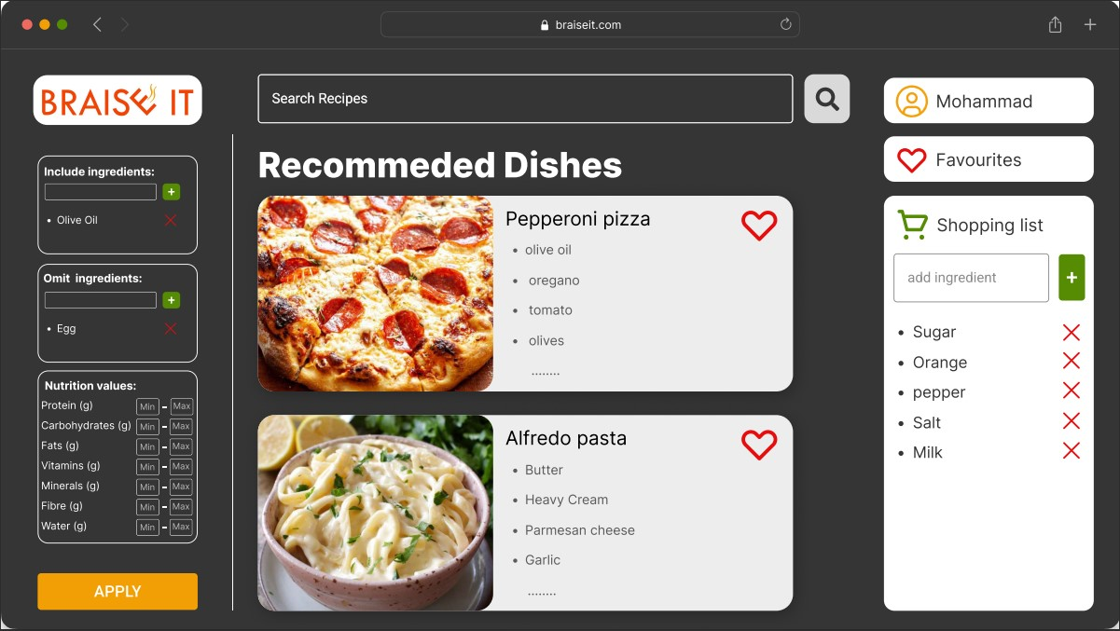

3.Recipe page

If you display this page, you have to go src/containers/leftX/bottomX/BottomX.js.

And select part1 as follows.

 return (

    <div className='w-full flex flex-row mt-10 space-x-10'>

     {/* // Part1 */}

      {/* <LeftB1 />

      <RightB1/>   */}

      {/* // Part2          */}

      <LeftB2 />

      <div className='mt-5'></div>

      <RightB2/>

    </div>

  );

Then you will show you like this.

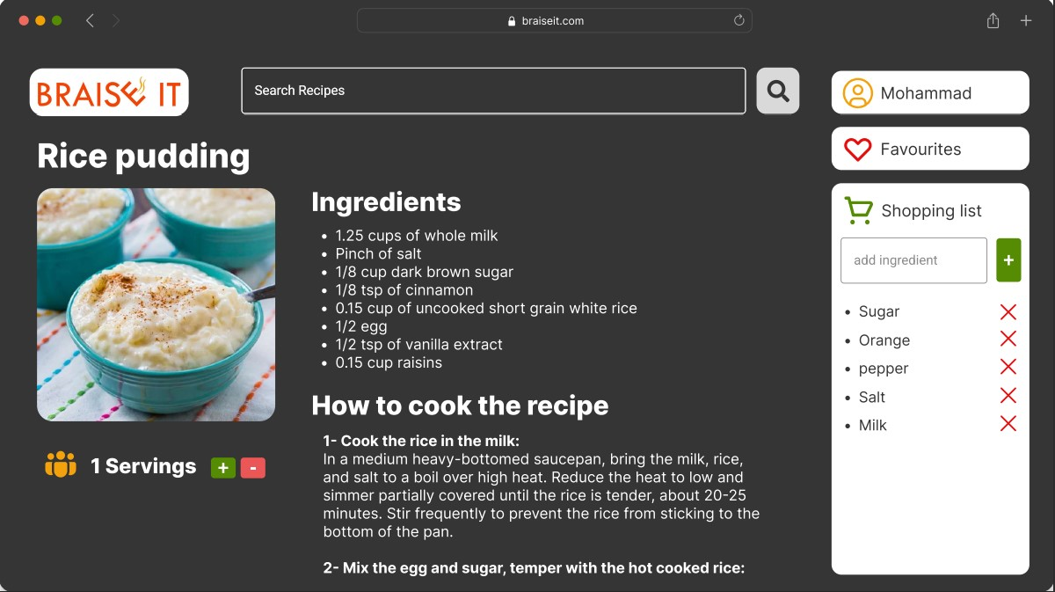

Thank you for visiting my work from Green team.